|  |
| --- |
| Your Cystic Fibrosis Application |
| Functional specification   Name: Lorcan BerminghamStudent Number: C00196903November 6, 2017 |

### Tutor: Dr Joseph Keogh

Contents

Abstract 3

Use Case Diagram 3

Brief use case 4

Patient Login 4

Patient Logout 4

Patient Register 5

Administrator Register 5

Doctor Login 6

Doctor Logout 6

Manage Patients 7

Food Diary 7

Process Food Diary 8

Process Manage Patients 8

Manage Account 9

Process Account Creation 9

Process Login 10

Process Activity 10

Process Spirometer 11

Supplementary Specification 11

Functionality 11

Usability 11

Reliability 11

Performance 12

Supportability 12

Iteration Plan 12

Iteration 1 12

Iteration 2 12

Iteration 3 12

Iteration 4 13

## Abstract

The point of this document is to give the reader the overall feeling of the application. The document provides a view of what the application is going to do and how it will work internally.

## Use Case Diagram

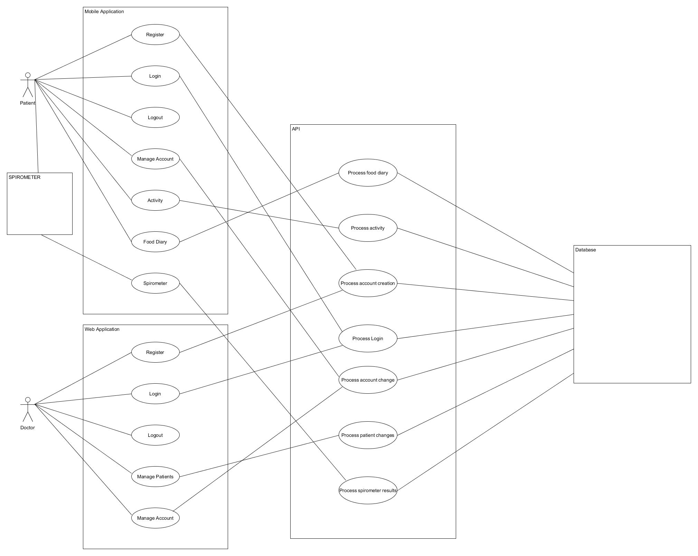

## Brief use case

### Patient Login

|  |  |
| --- | --- |
| Name | Patient Login |
| Actors | Patient, Mobile App, API |
| Preconditions | The patient has downloaded the CFAPP |
| Activity | Begins when the patient opens the mobile app. The system listens for the input of patient’s credentials (username. Password). The credentials are sent to the API for validation purposes. |
| Consequences | The API performs validation on the patient's login credentials that were entered |

### Patient Logout

|  |  |
| --- | --- |
| Name | Patient Logout |
| Actors | Patient, Mobile App |
| Preconditions | The patient has successfully logged into the system. |
| Activity | Begins when a patient has finished with the application. The patient selects the logout button then they are prompted if they really want to logout and confirm that they do. |
| Consequences | The patient is logged out. |

### Patient Register

|  |  |
| --- | --- |
| Name | Register |
| Actors | Patient, Mobile/Web App, API, Database |
| Preconditions | The mobile app has successfully loaded. |
| Activity | Begins when a patient/doctor opens the mobile app. The patient/doctor clicks the register button and a new page appears. The patient/doctor will be prompted either to sign in with their google, Facebook or setup one using their own email account. The account creation request is sent to the API for processing. |
| Consequences | The API processes the patient/doctor register request. |

### Administrator Register

|  |  |
| --- | --- |
| Name | Administrator Register |
| Actors | Admin, Web App, API, Database |
| Preconditions | The web app has successfully loaded. |
| Activity | Begins when an Administrator opens the web app. The admin clicks the register button and a new page appears. The admin will then register a new doctor to the system. The account creation request is sent to the API for processing. |
| Consequences | The API processes the patient/doctor register request. |

### 

### 

### Doctor Login

|  |  |
| --- | --- |
| Name | Doctor Login |
| Actors | Doctor, Web App, API |
| Preconditions | The web app has successfully loaded and the initial login screen successfully presented itself. The doctor has already signed up for an account. |
| Activity | Begins when the doctor starts the web app in their browser. The web app listens for the input of the doctor's credentials. The credentials are sent to the API for validation |
| Consequences | Once validation has taken place. The homepage of the web app is displayed to the doctor. |

### Doctor Logout

|  |  |
| --- | --- |
| Name | Doctor Logout |
| Actors | Doctor, Web App |
| Preconditions | The doctor has successfully logged into the web app. |
| Activity | Begins when the doctor has completed all interactions with the web app. The doctor selects logout button and is asked to confirm selection. The doctor is then logged out. |
| Consequences | The doctor is redirected to the login screen of the web app. |

### 

### Manage Patients

|  |  |
| --- | --- |
| Name | Manage Patients |
| Actors | Doctor, Web App, API |
| Preconditions | The doctor has already logged into the web app |
| Activity | Begins when a doctor clicks a patient tab on the web app. The website then loads the patient screen and the doctor can view and manage their patients. |
| Consequences | The changes/notes are sent to the API for processing. |

### Food Diary

|  |  |
| --- | --- |
| Name | Food diary |
| Actors | Patient, Mobile App, API, Database |
| Preconditions | The patient has successfully logged on to the mobile app. |
| Activity | Begins when the patient clicks the food diary tab on their homepage. The mobile app displays the food diary screen and the patient can manage their food diary. This means that they can select meals, snacks, track Creon doses and supplements. |
| Consequences | The changes are sent to the API for processing. |

### Process Food Diary

|  |  |
| --- | --- |
| Name | Process Food Diary |
| Actors | Patient, Mobile App, API, Database |
| Preconditions | The Patient has make changes to their food diary. |
| Activity | Begins when a Patient selects the update button on their food diary and the changes are sent to the API. The API then validates the request. |
| Consequences | Once validation takes place on the updated food diary it stores it in the database. The Patient is redirected to the food diary home page. |

### Process Manage Patients

|  |  |
| --- | --- |
| Name | Process Manage Patients |
| Actors | Doctor, Web App API, Database |
| Preconditions | The Doctor has successfully logged into the web app. |
| Activity | Begins when a Doctor clicks the manage patients tab and is brought to the manage patient screen where they can select a patient and view their data and make notes depending on how they are doing these notes are is sent to the API. The API then validates the request. |
| Consequences | Once validation takes place the API the notes are stored it in the database. The Doctor is redirected to the manage patient page. |

### 

### Manage Account

|  |  |
| --- | --- |
| Name | Manage Account |
| Actors | Patient, Doctor, Mobile App, Web App API, Database |
| Preconditions | The patient and doctor have successfully logged into the mobile app. |
| Activity | Begins when a Patient/Doctor navigates to their profile page in the mobile app. Patient/Doctor are presented with the option to change their basic information is sent to the API. The API then validates the request. |
| Consequences | Once validation takes place the API makes the changes to the profile of the Doctor/Patient and saves it to the database |

### 

### Process Account Creation

|  |  |
| --- | --- |
| Name | Process Account Creation |
| Actors | Patient, Doctor, Mobile App, Web App API, Database |
| Preconditions | The Doctor/Patient has successfully completed the registration form to create a profile. |
| Activity | Begins when a Doctor/Patient clicks the submit button and the request to register and create a profile is sent to the API. The API then validates the request. |
| Consequences | Once validation takes place the API creates Doctor/Patient and stores it in the database. The Doctor/Patient are redirected to login on their respective apps. |

### Process Login

|  |  |
| --- | --- |
| Name | Process Login |
| Actors | Patient, Doctor, Mobile App, Web App API, Database |
| Preconditions | The Doctor/Patient have created a profile and logged in. |
| Activity | The Doctor/Patient has previously created a profile. The Doctor/Patient has entered their login credentials and pressed login. |
| Consequences | Once a match in credentials takes place the Doctor/Patient is granted access to their respective homepages. |

### Process Activity

|  |  |
| --- | --- |
| Name | Process Activity |
| Actors | Patient, Mobile App, Database |
| Preconditions | The Patient have created a profile and logged in. |
| Activity | The Patient selects the activity option from the main menu. The patient then selects with level of activity they wish to participate in and is given the relevant options for that level |
| Consequences | The patient participates in the activity and then their score is sent to the database. |

### 

### Process Spirometer

|  |  |
| --- | --- |
| Name | Process Spirometer |
| Actors | Spirometer, Patient |
| Preconditions | The patient is logged into the application |
| Activity | The activity starts when the patient is logged into the system and retrieves a push notification to use the Spirometer. The patient then uses the spirometer three times and the application will get the time and the average of the three attempts. |
| Consequences | The patients attempt is recorded and sent to firebase. |

## 

## Supplementary Specification

### Functionality

The mobile and web applications must have access to the internet to interact with the API and database to access the data.

### Usability

A patient should be able to create a profile in less than 5 minutes. Once logged on a patient shouldn't have to logout. The applications should be user friendly and while navigating through the application it should give the user the feeling that they know where everything is.

### Reliability

In the case of a failure in data retrieval or verification, the user interface should stay responsive. Also, the application needs to be able to store motion and other data if a connection drops. It should then relay the information to the database once internet has been re-established.

### 

### Performance

The user interface should load in a timely manner. This is to not make the user feel as if they are waiting for extended periods of time to load pages.

### Supportability

Support for multiple browsers must be added without negative impact on the mobile/web applications.

## Iteration Plan

### Iteration 1

The first iteration consisted of the login/registration and the food diary. The food diary is the first page a patient will see after they have registered or logged in. The food diary acts as the home page as it will be one of the most used pages. A patient will have the ability to select Breakfast, Lunch, Dinner and Snacks. Each of the meals have many options that a patient can choose from.

The system works as follows:

The patient will be given a daily calorie figure by their dietitian to meet each day. When the patient selects a type of food it will have the calorie amount and the system will then take that amount away from the set calorie amount.

### Iteration 2

The second iteration consists of the activity. This is basically to monitor the amount of physical activity a patient takes part in over the three-month period.

The system works as follows:

The patient will have three separate types of activity on a scale from moderate straight through to intensive. The application will also give advice of the types of exercise that a patient should be doing. Once a patient selects one of the predefined activities and the amount of time they are going to spend doing the activity the system will take that activities score and multiple that by the amount of time and store that figure in the database.

### Iteration 3

The third iteration consists of the spirometer. This monitors the patient’s lung function once a week.

The system works as follows:

The patient will receive a push notification reminding them that they must take their spirometer measurement. The patient will then open the spirometer option from the menu. They will be met with a timer and three separate boxes one for each spirometer attempt. The patient will start the timer and take three reading entering each into its assigned box and then the will select the submit button. The system will take the three reading and find the average. Once the average has been calculated it and the time will be stored in the database.

### Iteration 4

The forth iteration consists of the doctor dash board. This will allow doctors to monitor their patients’ health throughout the three-month period.

The system will work as follows:

The doctor will log into their own dashboard. They will be able to monitor each of their patient’s food, activity and lung function at any point in between doctor appointments.